Hanna and Matt - Saturday 16th February 2019;
The Elvetham
Selfie station set up for whole day.
Dan arriving 09:00-09:30
08:30 – 13:00 | Hanna and Bridesmaids getting ready at The Elvetham in Seymour Room. Mother of the Bride arriving around 09:30. Florist (Becky Stevens) arriving at 10:00.  Photos of:-  - The usual getting ready photos  - Dress and personalised hanger details  - Dress/Shoes/Flowers/Perfume etc.  - Photos of the grounds  - Robe photos  - Gifts that are laid out on table with special bags – gifts given at 11:30  - Letter opening (to Hanna from Matt) before make up  - Make up/hair to be finished by 13:00. (Hair and makeup by Kayleigh Knox)  - Bridesmaids receiving gifts  - Dress to be put on at 1pm  - Mother of the Bride zipping up dress at 13:20  - Reveal photo to father of the bride & bridesmaids (through secret door) at 13:30
10:30 – 12:00 | Matt and his BM/Ushers getting ready at The Elvetham in room 110.  Photos of:-  - The usual groom prep photos  - Stage shots by window  - Matt opening his gift and letter from Hanna (alone) once dressed  - Watch/cufflinks etc.
12:30– 13:30 | Matt and Groomsmen to go to bar.  Photos of:-  - Mother of the Groom attaching buttonholes  - The boys will all have bright neon socks if you could get photos of them lifting their trousers to reveal  - BM/Ushers receiving and putting on their gifts (socks, pocket watches)  - Few formal shots out the front with building. Line standing shots. Couple of fun ones.  - All the groomsmen holding groom
13:45 | Matt and groomsmen to go into Ceremony Room.  Photos of :-  - Ceremony room before guests come in  - BM/Ushers greeting guests (arrival 13:30-13:45)
14:00 | Ceremony:  Photos of:-  - Photo of Hanna & Lee (FoB) coming down staircase  - First look photo from Matt  - The usual ceremony photos (walking down the aisle, rings, signing register etc)  - First kiss in the middle  - Photos of those who are readings
14:30 | Cocktails and Canapés.  Photos of:-  - Confetti Shots (weather dependant)  - Mingling with guests  - Family/Bridal party photos  - Group photo  - Our private photos with you  - Shot of just the two of us in front of the building
These below group shots the best person to help round up people will be Jane and Kirsten.
- Bride, Groom, Mother and Father of the Bride
- (Hanna, Matt, Kirsten, Lee)
- Bride, Groom, Mother and Father of the Bride, Brother
- (Hanna, Matt, Kirsten, Lee, Dan)
- Bride, Groom, Mother, Father of the Bride, Brother, Mother, Father of the Groom, Sister
- (Hanna, Matt, Kirsten, Lee, Dan, Jane, Philip, Tess)
- Bride, Groom, Mother and Father of the Groom
- (Hanna, Matt, Jane, Philip)
- Bride, Groom, Mother and Father of the Groom, Sister
- (Hanna, Matt, Jane, Philip, Tess)
- Groom, Harding Uncles
- (Matt, Mark, Robert, Jonathan)
- Bride and Hen Party
  - (Hanna, Tess, Amy, Georgie, Jenny, Jenni, Anna, Jane, Helena, Brooke, Jane, Kay, Kirsten, Emily)
- Groom and Stag Party
  - (Matt, Ben S, Ben C, Chris M, Philip, Lee, Aaron, Tim, Robert, Mark, Jonathan, Louis, Freddie, James, Nick)
- Bride, Groom and Jones family
  - (Hanna, Matt, Kirsten, Lee, Sylvia, Chris J, Robyn, Andrew, Patsy, Jane W, Chris W)
- Bride, Groom and Kelly family
  - (Hanna, Matt, Lee, Kirsten, Roy, Elizabeth, John, Tracy, Ben K, Sam)
- Bride, Groom and Harding family
  - (Hanna, Matt, Jane, Philip, Robert, Marie, Caitlin, Lili, Jonathan, Faith, Daisy, Mark, Jenny, Joy)
- Bridal Party Photos
16:00-19:00 | Wedding Breakfast in the conservatory. No receiving line.  Photos of:-  - Conservatory with decorations (before guests arrive)  - Photo of us entering (after everyone else)  - Speeches will be at 17:30 between main course and dessert:  - Father of the Bride  - Groom  - Best Man  - Sunset at 17:20 ??
18:30-19:30 | Coffee and tea served at 18:30 in foyer  Evening guests arrive at 19:00  Photos of:-  - Wedding Cake & cake cutting at 19:00  - Bouquet throw after cake cutting at 19:10
19:30 | - First Dance at 19:30  - Immediately followed by Father of the Bride & Bride dance  - Sparkler Photos
21:00 | Evening Food served
21.45 | Photos of:-  - Additional night time shots  - Guests dancing  - Additional decorations  - Group photos of evening guests who weren’t in the day time
Photos of our VIP List:
Parents of the Bride (Kirsten and Lee); Brother of the Bride (Dan)
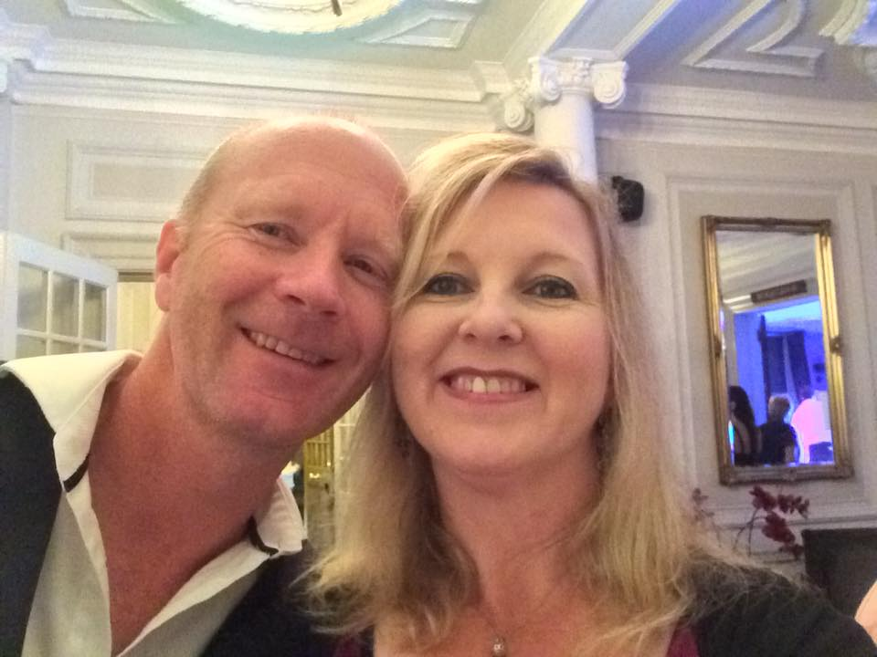
Parents of the Groom (Jane and Philip);

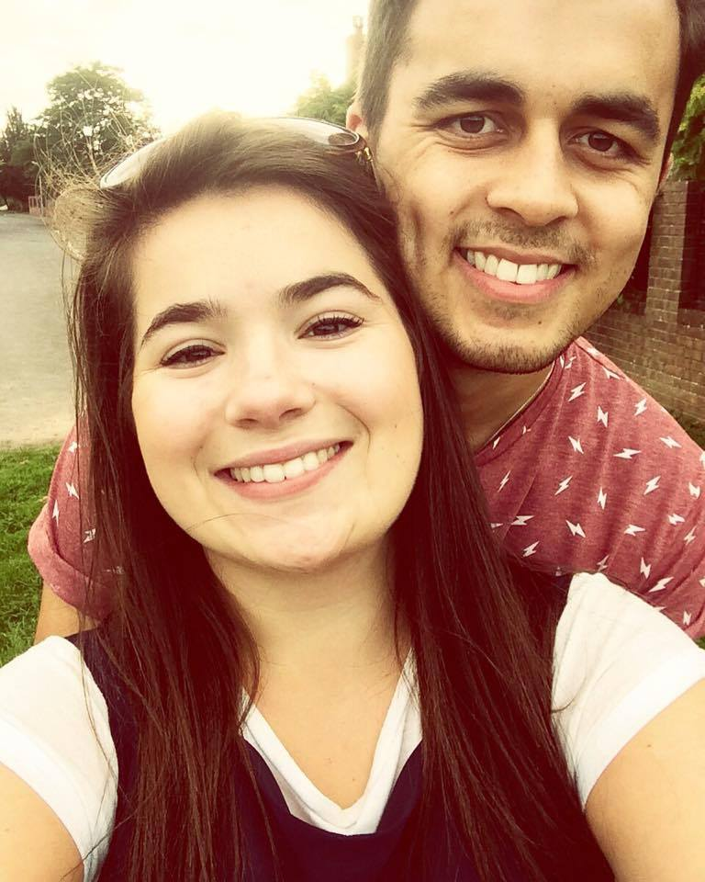
Sister of the Groom, Tess (also maid of honour) and Chris M (Usher)

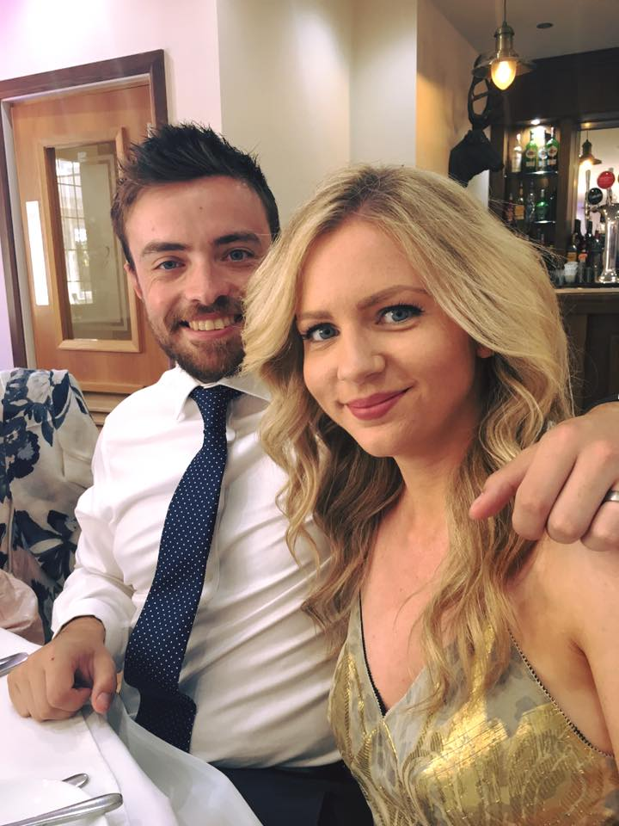
Best man and Bridesmaid: Ben Shaylor, Amy Shaylor

Bridesmaid (Georgie Burke) and Usher (Ben Claxton)

